Determining what to do when participant is using a substance or under the influence during an assessment or therapy session

Step 1: Look for symptoms of acute intoxication. Remember, these symptoms are to be used as a guide and do not definitely conclude a participant is intoxicated. The presence of these symptoms may trigger a more in-depth assessment of the participant’s cognitive abilities.
Loss of fine motor control –any impairment of activities requiring fine motor coordination (e.g., fumbling with cigarettes, difficulty in retrieving ID cards from wallet or purse).

Smell of alcohol-- odor of alcohol is evident when the assessor approaches the participant and engages in face-to-face conversation for several close exchanges (e.g., introductions and several question and answer exchanges).

Slurred speech-- any difficulty in enunciating words distinctly. This may be either a single error or several instances where words are indistinguishable or blurred so that speech is not articulated clearly and concisely.

Loss of gross motor control—participant may stumble over or accidentally brush against objects, or have difficulty maintaining upright posture. They may have difficulty walking in a reasonably straight line.

Decreased alertness--increased response time to environmental stimuli or direct questions posed by the assessor. Person may have difficulty paying attention to the conversation or following simple commands (e.g., may require extra repetition of conversation or commands in order to respond to or comply with a request for information or other directive).

Change in speech volume--deviation from normal conversational volume appropriate to situation (i.e., participant's voice overly loud when there is no competing background noise, or he may whisper or talk very softly when there is no apparent reason for confidentiality). Participant's voice may go from low to high or from high to low volume when there is no external cue indicating that a shift in volume is required.

Respiration slow or shallow--assessor can detect a discernible deviation in respiration compared to his own breathing or that of other people involved in the interaction.

Sweating--excessive perspiration is observed which is not due to temperature, or where sweating is too profuse to be accounted for by nervousness, physical exertion or any other external factor.

Pace of speech -- changes in rate of speaking (e.g., racing speech alternating with slow speech, or consistently slow or fast speech).

Sleepiness--person is tired; eyes may be closed ONLY when external factors, such as time of day, would not account for this behavior. The participant may be dozing in a situation where a higher level of attention is the norm for most people (e.g., in a public social situation such as a bar, on the street, in the emergency room or during interaction with police or other officials).

If you notice these signs or suspect a person may be intoxicated, proceed to the next steps.

Step 2: Conduct Pass/Fail tests to determine if participant is cognitively aware enough to complete the interview or therapy session at that time. Here you are assessing the potential for distortion or inaccuracy of the data the participant may provide:
- The participant does not have the ability to get through the survey or sessions:
  - If you have to repeatedly repeat a question or explain a question 3 different times, if the participant is continually falling asleep or nodding out, or if the participant is not able to form coherent thoughts, then the participant failed test #1.
- The participant does not have the ability to remember:
  - If the participant cannot repeat back what you say (for example, if you briefly explain what you plan to do during your time with them, and then you ask the participant to repeat back to you what you asked), if the participant cannot coherently answer (makes tangential statements, etc.), then the participant failed test #2.
- The participant cannot pass a cognitive exam:
  - Administer MMSE to the participant. If the participant cannot get a total score of 18 or more, then the participant failed test #3.

If the participant PASSES the MMSE, no further action needs to be taken. If you are concerned about the participant, you can encourage them to talk to their provider or treatment staff about their condition, however we CANNOT break confidentiality. A follow-up incident report must be completed.

If the participant FAILS the MMSE, it is LIKELY this person will provide us inaccurate data and the interview or session should be terminated. You should let the participant know that it seems like now is not a good time to continue the interview/session and that we would like to reschedule for a different time.

At this point, you should ask follow-up questions to gather information on how the participant plans to get home safely (e.g. “How did you get to the appointment today?”; “Do you have someone who can come and pick you up?”; “Would you be willing to wait here at the clinic for a while until it is safe for you to leave?”). Ideally, we would want the participant to do any of the following:
1) Agree to inform the treatment staff at the clinic that they are intoxicated
2) Agree to rest for a while at the clinic
3) Agree to call a friend for a ride home
4) Agree to take a cab or the bus
5) Agree to walk down to the ED (if at the VA hospital)

Once you have spoken to the participant about the next steps, you should call your supervisor and relay the information to them. If the supervisor agrees to the plan, you should help the participant towards whichever option they are comfortable with. A follow-up incident report must be completed.

If they refuse all of these options and they are insistent that they want to leave and they are taking a form of public transportation or are being picked up by a friend, you must allow the participant to leave, and no further notifications are needed. A follow-up incident report must be completed.

If they refuse all of these options and they are insistent that they want to leave and drive home, we will notify the participant that for patients leaving against medical advice and considered a danger to themselves or others, we are required to contact the VA police and/or local law enforcement officials. NOTE: When notifying law enforcement officials, no information protected by Title 38 United State Code (U.S.C.) 7332 (i.e., information related to the condition of sickle cell anemia or HIV or the condition and treatment of drug and/or alcohol abuse) may be disclosed. When contacting the local police, the patient should not be described as intoxicated but instead, the patient could be described as “impaired” or “incapable of driving”. Following the notification of the authorities, the following should be done:
1) A note should be placed in CPRS documenting the need to notify the authorities.
2) An incident report must be completed.
3) A supervisor must be e-mailed regarding the incident so that an ORIO (or UAP) can be submitted to the IRB.

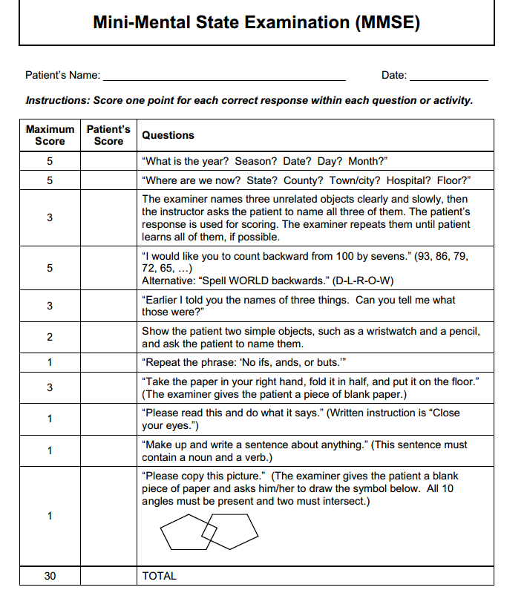

Summary Flowchart
Is the participant showing any physical signs of intoxication or impairment?

- Remind participant of the limit of confidentiality in instances where they may be a danger to themselves or others.
- Notify appropriate authorities.
- Be sure to state that the participant is “impaired” or “incapable of driving”, not “intoxicated”.
-Documentation needed:
- CPRS notes entered
- Internal documentation
-Notification to IRB is necessary

-Stay with participant until contact with clinical professional has been established.
-Internal documentation needed.

IF NO
IF YES
- Confirm the participant has a safe way home (e.g. the bus, a cab, a friend, etc.) and allow them to leave.
-Internal documentation needed.
FOR PUBLIC TRANSPORTATION
FOR DRIVERS
Is participant willing and able to disclose risk to clinician, remain at the clinic until safe, or go to the ED?
-End the assessment/session and reschedule for a different time.
-Ask follow-up questions regarding transportation.
-Come up with a plan that will keep the participant safe (i.e. notify a clinician, rest in the clinic, call a friend/cab, take them to ED).
-Call supervisor to confirm plan.

IF NO
-No further involvement necessary; can continue the assessment/session
-Encourage the participant to speak to someone if concerned, but CANNOT break confidentiality.
-Internal documentation needed.
IF NO
IF YES
Did the participant score an 18 OR GREATER on the Mini Mental Status Exam (MMSE)?
IF YES
-Continue the assessment/session
-No Documentation needed
IF NO
Is the participant showing any cognitive signs of intoxication or impairment (inability to following along, understand, remember, etc.)?

IF YES
-Continue the assessment/session
-No Documentation needed
IF NO

