Meeting/Project Name: | ORD SPR Advisory Group Monthly Meeting
Date of Meeting: | Tuesday, June 25th , 2024 | Time: | 3:00-4:00 PM ET
Meeting Facilitator: | J. Constans | Location: | MS Teams

MEETING OBJECTIVE
Provide the committee with updates and address next steps for future initiatives and projects

ATTENDEES LIST (check mark indicates attendance)
Committee Members: | ☒ Dr. Bob O'Brien  ☒ Dr. Joseph Constans | ☐ Dr. Miriam Smyth  ☒ Dr. Peter Hunt | ☐ Dr. Vetisha McClair
Advisory Group: | ☒ Dr. Steven Dobscha  ☒ Dr. Stephanie Gamble  ☒ Dr. Brian Marx  ☒ Dr. Bradley V. Watts  ☒ Dr. Edgar Villarreal | ☒ Dr. Stephen O’Connor  ☒ Dr. Susan Strickland  ☒ Dr. Melissa Mehalick  ☒ Dr. David Atkins | ☒ Dr. Wendy Tenhula  ☒ Dr. Lisa Brenner  ☐ Dr. Matthew Miller  ☒ Dr. Jodie Trafton
Others: | ☒ Caroline Mwonga  ☒ Dr. Kara Beck
Support Staff: | ☒ Imani Braxton-Allen (Titan Alpha)

MEETING NOTES
Agenda:
- Review Results of Priority Setting
- Discuss Results
- Broad NOSI
- Specific NOSI
- Next Steps
Notes:

- Results of Priority Setting
  - Key Priority Areas
    - Lethal Means Safety
    - Community-based intervention
    - Family and social network-based interventions and postventions
    - Psychotherapies and other non-somatic interventions
    - Suicide risk screening, evaluation effectiveness, and processes within VA; predictive analytics
  - On June 4th, we held a voting session where voting members ranked these critical research priorities in terms of importance.
  - We had presentations from the Office of Suicide Prevention ,Center of Excellence, Rocky Mountain MIRECC, and the Office of Rural Health Projects
  - There are 10 voting members in total, 9 out of the 10 voted and 5 out of the 9 were present during the voting session. The other 4 did their voting outside of the meeting after reviewing the presentations and recording or talking with Dr. Constans.
  - Ranking Process:
    - 9 individuals ranked 5 CRP options from highest priority (first position) to lowest priority (last position) using a Microsoft Forms (MS Forms) Survey.
  - Ranking Products:
    - Strategy 1 – The highest priority (first position) was assigned the highest numerical value (5), and the lowest priority (last position) was assigned the lowest numerical value (1). MS Forms calculated the total score for each option by summing the values assigned by all respondents.
    - Strategy 2 – Domain with highest number of Rank #1 votes.

- Discussion of voting results
  - At the individual level voting,
    - lethal means safety had 5 first place votes
    - Community based interventions had 3 first place votes
    - Lethal means safety was never chosen as a 4th or 5th rank

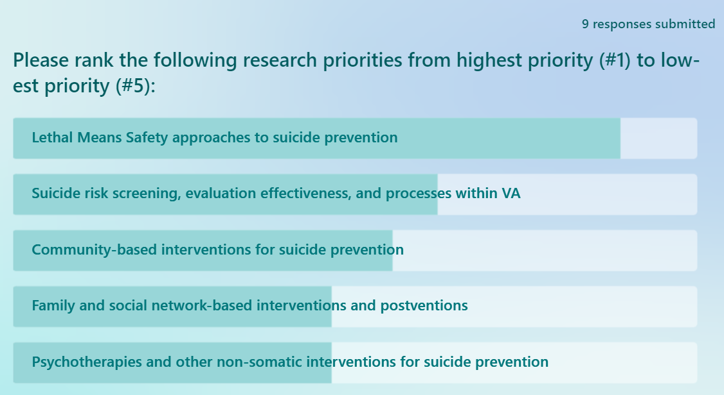
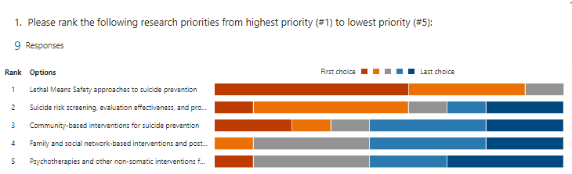

- NOSI (Notice of Special Interest)
  - Revised Research Application Process under the new re-org
    - Post ORD-Wide RFAs: ISRM publishes ORD wide RFAs for research types
    - Notice of Special Interest: Portfolios release NOSI to indicate their purviews and priority areas
    - Request Pre-application: Each portfolio utilizes eRa Pre-Application (PA) requesting information on the proposed study and specific SRG request
    - Submit pre-application: Investigators submit Pas through a Portfolio PA RFA. Portfolio reviews Pas and accepts, rejects, or reassigns.
    - Submit full application: Investigators submit full proposals through ORD wide RFas into eRA including their PA acceptance letter.
    - Review/score applications: SRG reviews/scores the application and then goes to a Portfolio ranking meeting
    - *Rankings go to the ISRM Leadership Council which establishes a pay line*
  - NOSIs for Suicide Prevention AMP
    - Moving with Suicide Prevention, there will be two kinds of NOSIs. One will be more broad and for suicide prevention research in general and one will be more focused. The focused NOSI will be based on our priority frames.
    - This will allow applicants to apple for the broad or focused NOSI.
    - It is inferred that the broad NOSI will have a long lifespan
    - Broad NOSI:
      - Capture SP studies across translational science spectrum
      - Have a long timeline (5 years)
      - Responsive to full range of investigator-initiated research proposals
      - Based on SP Purview Statement
    - Specific NOSI based on AMP priorities:
      - Capture SP studies responsive to identified priority
      - Have shorter timeline (2 years)
      - Will evolve over time.
      - May be multiple Specific NOSIs
      - Will include recommended topics SMEs recommended to advance state of the science.
- Notes/Questions
  - Proposing to have a specific NOSI for lethal means safety based on the outcome of the priority setting and the budget being somewhat tight.
  - How is the budget determined?
    - The budget is determined based off the RFA and not the NOSI itself.
- Next Steps
  - July 25-NOSI
    - Priority NOSI
  - July 25 & August 27
    - Review of existing portfolio
    - Review budget for FY25

ACTION ITEMS
- Develop a specific NOSI based on lethal means safety and one broad/general NOSI

