SPTD Data Story 1: What Suicide Prevention Interventions Have Been Studied?
The Suicide Prevention Trials Database (SPTD) was designed to identify studies of suicide prevention interventions and abstract detailed study-level data in a standardized manner into a publicly accessible database. Many aspects of this project are based on a similar database for studies of PTSD treatment trials, the PTSD-Repository, available through the National Center for PTSD at PTSD-Repository (socrata.com). The first phase of the SPTD included data from randomized control trials (RCTs) that were published between 1980 and 2023 with a primary aim of preventing suicide or suicidal self-directed violence. RCTs are one of the best scientific methods for testing the effectiveness of an intervention. In an RCT, participants are assigned at random to an intervention group or a control/comparison group. The random assignment of study participants helps balance participant characteristics across the groups. This increases the confidence that differences in outcomes between the intervention and control/comparison groups are due to the intervention rather than participant characteristics (i.e., “confounders”). The following data story examines the interventions that were tested by the studies included in Phase 1 of the SPTD.
How is primary intervention type defined?
RCTs have at least two test groups, or “arms,” – a control/comparison group, and an intervention group. The intervention group is the treatment the study is testing to estimate effectiveness. In Phase 1 of the SPTD, we identified 129 studies (92.1%) that had two arms and 11 studies (7.9%) that had three arms; no studies had more than three arms. In the studies with three arms, there were two intervention groups, and a control/comparison group. For each study, information on the intervention type of each arm was abstracted. Studies were then classified according to the intervention(s) being tested. For example, there are 35 studies in the database with two arms which include an intervention arm classified as “Behavioral” and a control/comparison arm classified as “Treatment as Usual.” In these cases, the primary intervention type of these studies was defined as Behavioral. In the 11 studies with three arms, nine had the same intervention category for both intervention arms being tested. These were classified the same way as the studies that had two arms. The two remaining studies had different intervention categories for the two intervention arms being tested. These two studies tested a “Behavioral” intervention and a “Care Management, Follow- up, or Monitoring” intervention compared to a “Treatment as Usual” control/comparison group. In these cases, the studies were classified as “Behavioral.” Finally, it is possible that a study tested a combination of interventions together. For example, the intervention of a study could be classified as both “Behavioral” and “Care Management, Follow-up, or Monitoring.” We categorized these studies as “Multiple” interventions. We include a section in this data story with more detail on the types of “Multiple” interventions that were tested.
Primary Intervention Categories
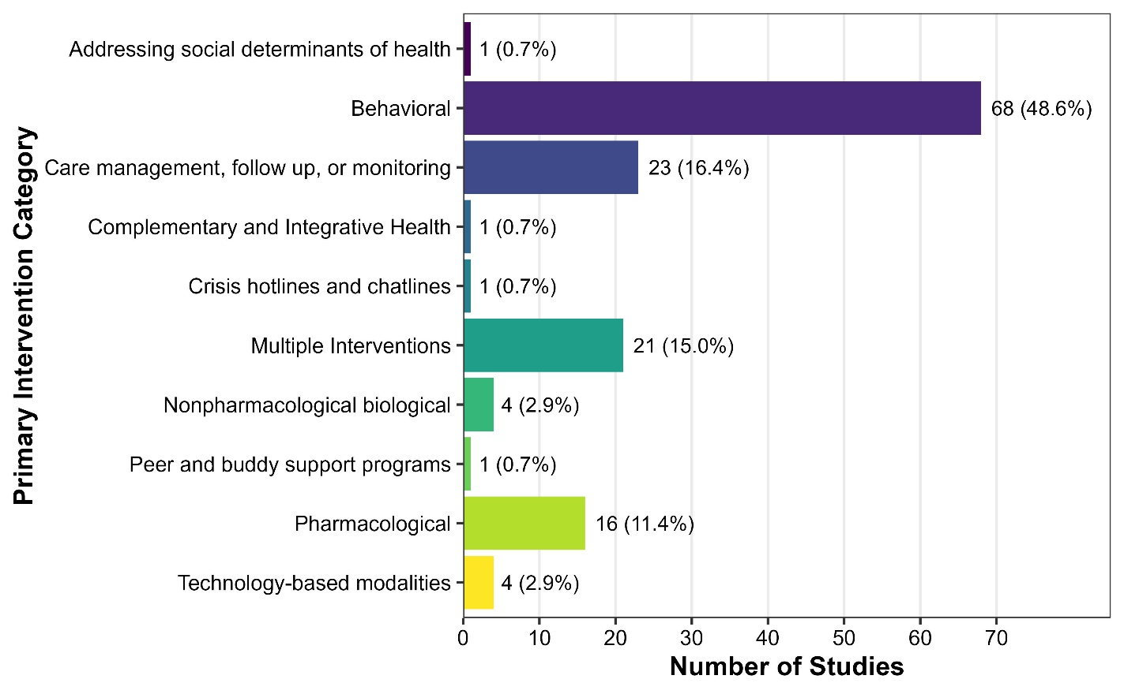
In the 140 studies included in Phase 1 of the SPTD, interventions from nine primary intervention categories were tested. Behavioral interventions, including Cognitive Behavioral Therapy, Dialectical Behavior Therapy, and Problem-solving Psychotherapies were the most common (n = 68, 48.6%). The next most common primary intervention category was Care Management, Follow-up, or Monitoring (n = 23, 16.4%), which includes interventions such as CAMS, home visits, and collaborative care. As described above, studies categorized in the Multiple primary interventions category (n = 21, 15.0%) will be described in further detail in a subsequent section. There were 16 studies (11.4%) with a Pharmacological intervention - these included Ketamine, Lithium, Clozapine, and selective serotonin reuptake inhibitor (SSRI) drugs. For additional definitions of SPTD Primary Intervention categories, see the SPTD Data Dictionary.
Number of Studies by Primary Intervention Category
SPTD Phase 1 Dataset; N = 140 Studies
The Multiple Interventions category includes studies that delivered interventions from more than one category, e.g., Behavioral and Care Management, Follow-up, or Monitoring.

Interventions over Time
Over the years evaluated, there have been increasing numbers of RCTs published on suicide prevention interventions, and there have also been more categories of suicide prevention interventions tested. Between 1980 and 1989 there were five studies published that met criteria for inclusion in the SPTD. One decade later, from 2000 to 2009, a total of 25 studies were published. In this decade, the first study of a Complementary and Integrative Health intervention was published. In the most recent full decade examined, between 2010 and 2019, a total of 66 studies were published in which treatments from eight primary intervention categories were tested. The new primary intervention categories studied during this decade included Nonpharmacological Biological, Technology-based Modalities, Peer and Buddy Support Programs, and Addressing Social Determinants of Health. Finally, in the most recent four years, from 2020 to 2023, there were 33 studies published that examined treatments from seven primary intervention categories. The one new primary intervention category examined during this period was Crisis hotlines and chatlines. Over time, Behavioral; Care Management, Follow up, or Monitoring; and Pharmacological interventions have consistently been those most studied.
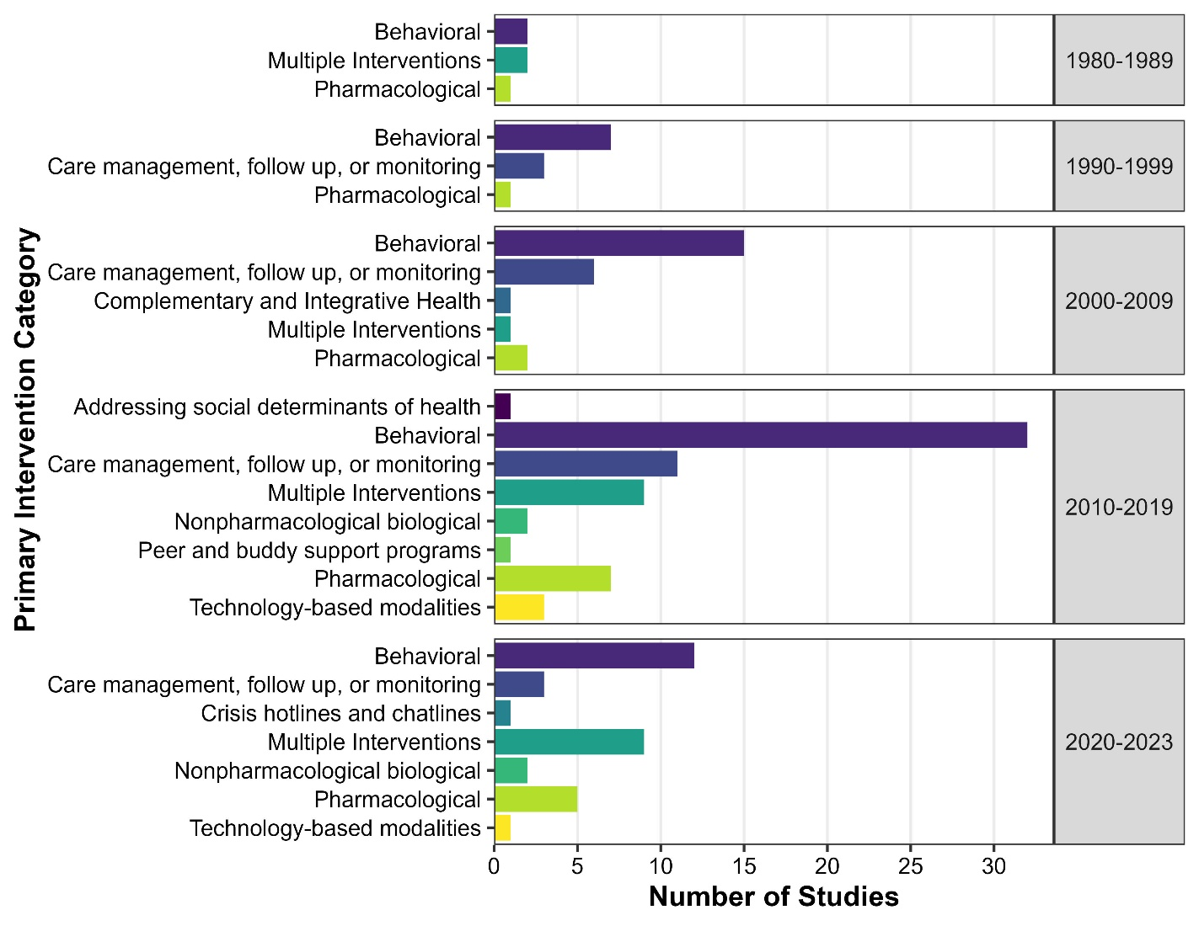
Number of Studies by Decade and Primary Intervention Category
SPTD Phase 1 Dataset; N = 140 Studies
The Multiple Interventions category includes studies that delivered interventions from more than one category, e.g., Behavioral and Care Management, Follow-up, or Monitoring.
Multiple Interventions
There are 21 studies in the SPTD with a primary intervention category of Multiple; almost all of these (n = 20; 95.2%) included Behavioral intervention components. The most common interventions to be combined were Behavioral and Care Management, Follow-Up, or Monitoring (n = 16, 76.2%). The other four studies that included a Behavioral component tested Behavioral and Time and Attention Control, Behavioral and Pharmacological, and Behavioral and Technology-based Modalities. One study tested Multiple interventions that did not include a Behavioral component; this study tested a treatment that combined interventions categorized as Care Management, Follow-up, or Monitoring with Complementary and Integrative Health.

Intervention Format
Primary intervention “format” describes whether the intervention was delivered to an Individual, Group, Family/Couples, and Other. It is possible for an intervention to have more than one format. Most studies (n = 110, 78.6%) tested a primary intervention with an Individual format. The second most common intervention format was Group combined with Individual (“Group; Individual”; (n = 17, 12.1%), followed by Group-alone (n = 6, 4.3%). To date, all studies included in the SPTD have tested an intervention format that involved either individual or group components.
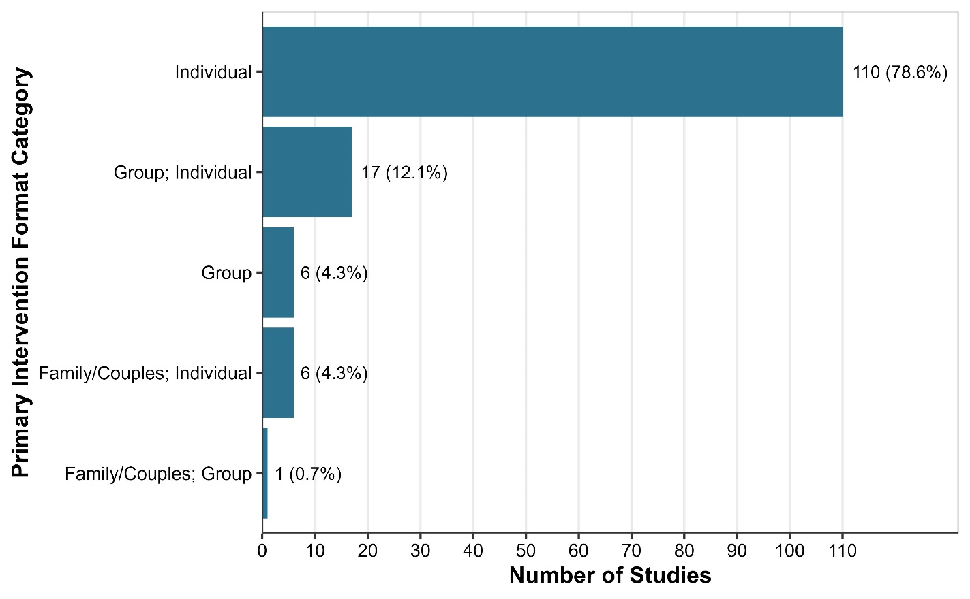
Number of Studies by Primary Intervention Format
SPTD Phase 1 Dataset; N = 140 Studies

Intervention Delivery Method
The “delivery method” describes how the intervention was delivered to the participant. Categories included In-person, Phone, Video, Technology-alone, Technology-assisted, Written, and Other; interventions may have more than one delivery method. In the studies included in the SPTD to date, the most common delivery method was In-Person (n = 86, 61.4%), followed by In-Person and Phone (“In-person; Phone”; (n = 22, 15.7%), and Technology-alone (n = 7, 5.0%).
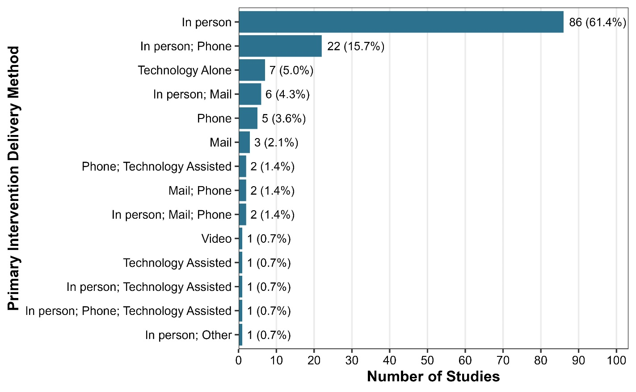
Number of Studies by Primary Intervention Delivery Method
SPTD Phase 1 Dataset; N = 140 Studies

Suicide Prevention Stage
The Prevention Stage category describes the study’s stage of prevention, based on the intervention’s approach and target population, using a public health framework. The possible options for suicide Prevention Stage were Universal, Selected, Indicated, or Other. It was also possible for a study to have more than one Suicide Prevention Stage. A Suicide Prevention Stage of Indicated means that the intervention targeted participants with a history of suicidal ideation, attempts, or psychiatric hospitalization. Selected interventions targeted participants with a history of mental health disorders or other characteristics associated with a higher risk for suicide, but no history of suicidal ideation, attempts, or psychiatric hospitalization. All studies in phase 1 of the SPTD have a Suicide Prevention Stage of either Indicated or Selected. Indicated was the most common Suicide Prevention Stage (n = 118, 84.3%). There were n = 22 studies (15.7%) in the SPTD with a Suicide Prevention Stage of Indicated. Similar intervention types were tested for these two categories; however, no Peer and Buddy Support Programs, Complementary and Integrative Health, or Crisis hotlines and chatline interventions were tested in studies with a Selected Suicide Prevention Stage. There was one Selected study which examined an intervention that addressed Social Determinants of Health, while no studies in the Indicated category tested an intervention in this category.
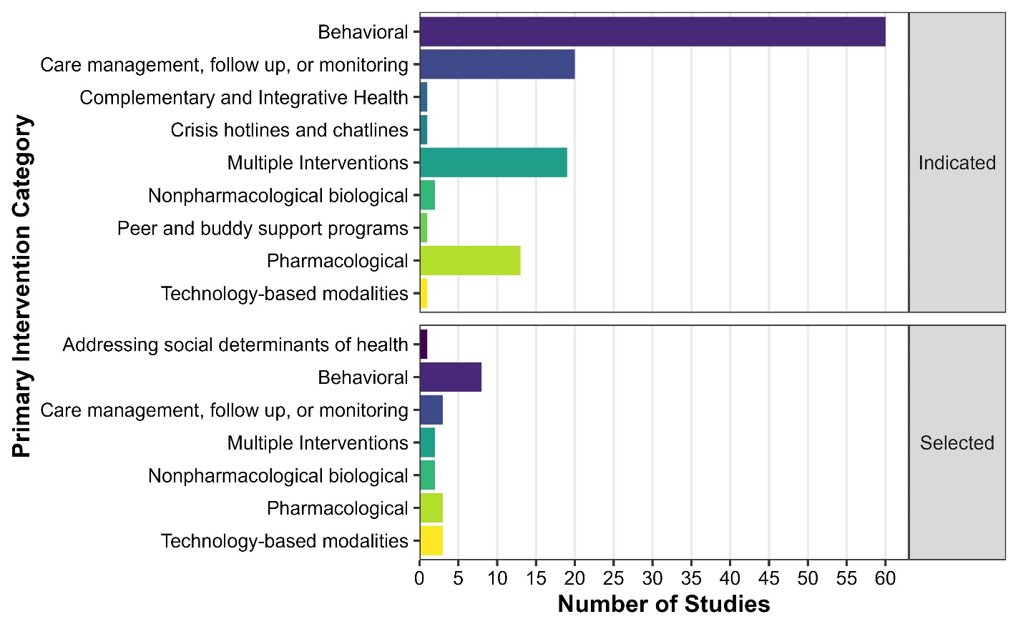
Number of Studies by Primary Intervention and Suicide Prevention Stage
SPTD Phase 1 Dataset; N = 140 Studies
The Multiple Interventions category includes studies that delivered interventions from more than one category, e.g., Behavioral and Care Management, Follow-up, or Monitoring.
VA/DOD Settings
Studies were categorized according to the setting in which they took place. Categories included Department of Veterans Affairs (VA), Department of Defense (DoD), Civilian, Other, or a Combination of these settings. Most studies described in Phase 1 of the SPTD took place in a Civilian setting (n = 122, 87.1%). Seven studies took place at DoD sites, one took place at a combined DoD and VA site, and ten took place at VA sites. The Multiple Interventions for these studies consisted of a combination of Behavioral and Care management, follow up, or monitoring.
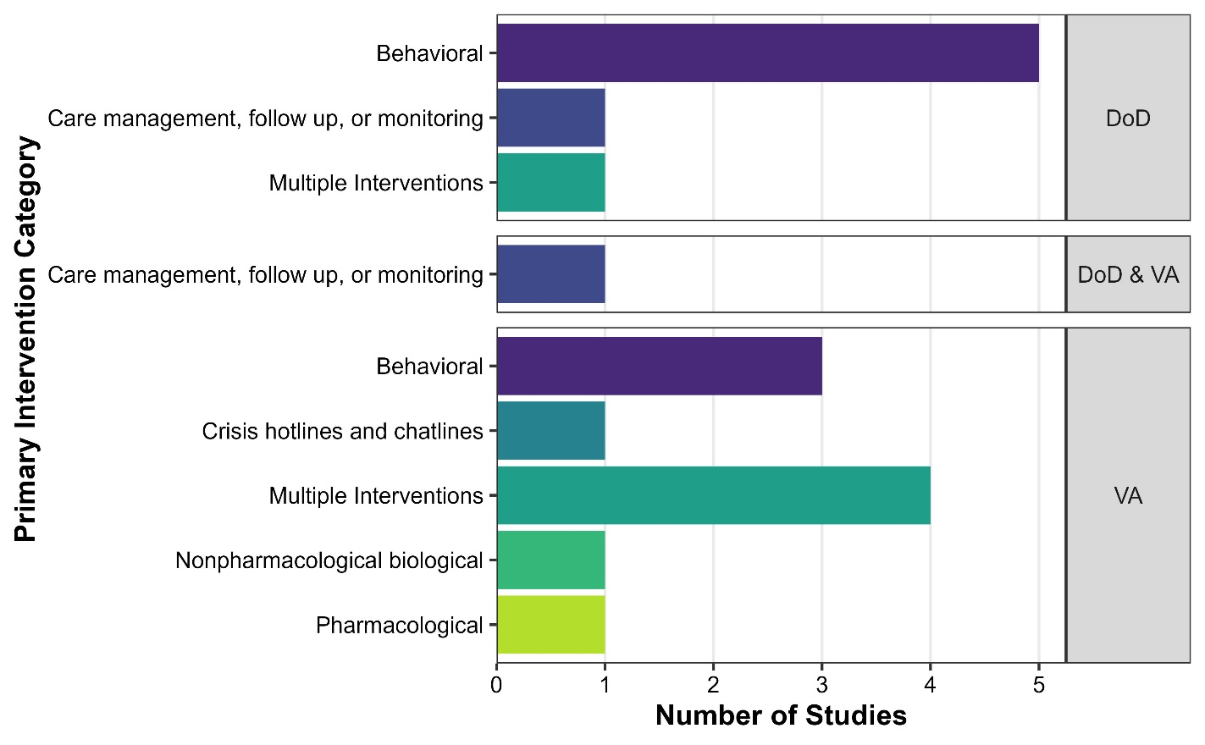
Number of Studies by Primary Intervention and VA/DOD Setting Category
SPTD Phase 1 Dataset; N = 140 Studies
The Multiple Interventions category includes studies that delivered interventions from more than one category, e.g., Behavioral and Care Management, Follow-up, or Monitoring.

Control/Comparison Group Types
Studies included a variety of different “control” group types, against which the interventions being tested were compared, and some compared interventions to other active intervention comparators (e.g., a behavioral intervention compared to a pharmacological intervention). Control group types were categorized as Treatment as Usual; Placebo/Sham; and Waitlist or Other Passive Control. Most studies in the SPTD used a Treatment as Usual as the control/comparison group type (n = 74, 52.9%).
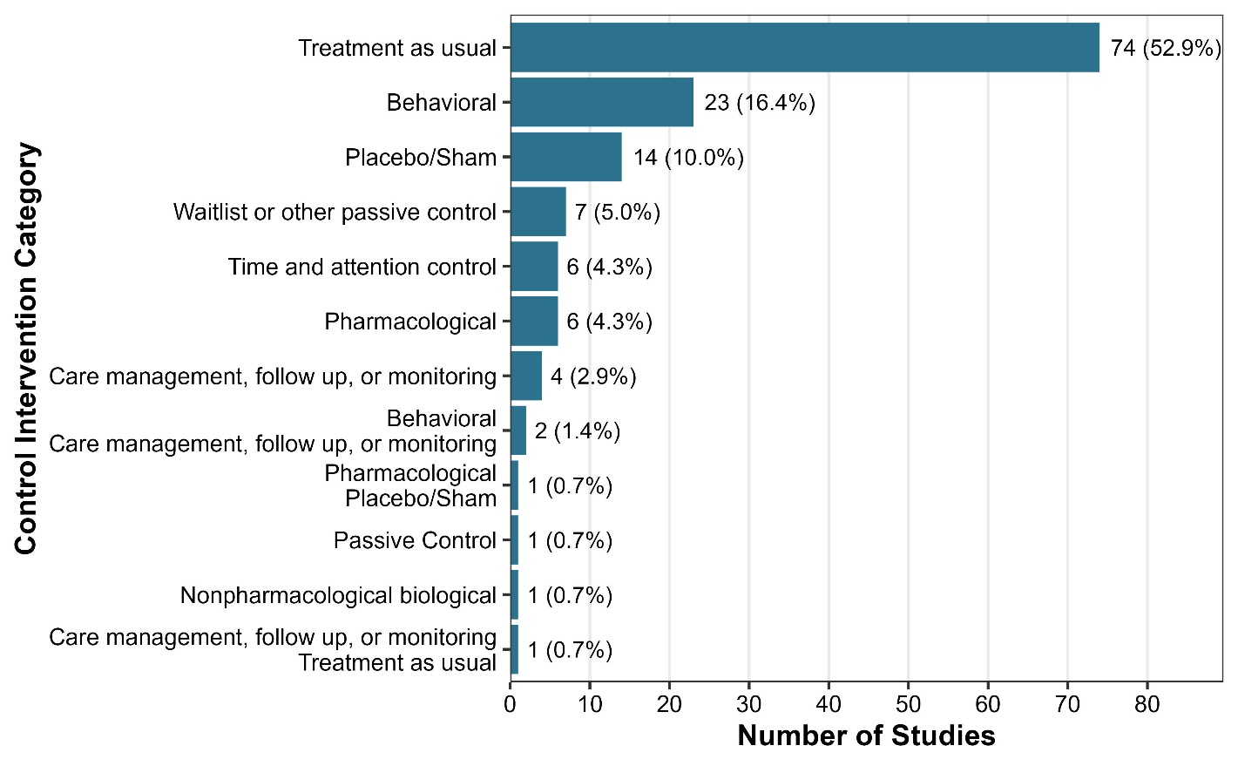
Number of Studies by Control/Comparison Group Type
SPTD Phase 1 Dataset; N = 140 Studies

